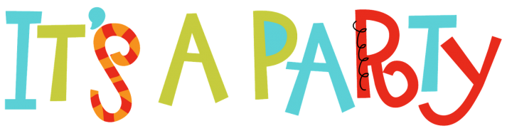

You’re invited to a birthday party for

[Name]

on [Day, Month, Date] at [Time]
[Location]

RSVP to [Name] at [Contact Info]

In lieu of gifts, [Name] asks that you bring
basic needs items to donate to teen mothers and
their children at Florence Crittenton Services.
You can find a wish list of items included with this invitation.

